Module 1

Assignment 1.3
Course: CSD402-340A Java for Programmers
Prepared By: Mirach Erkol
Date of Report: 11/18/2025

https://github.com/Mikey5007/csd-402.git

1.3 Assignment: Java Installation
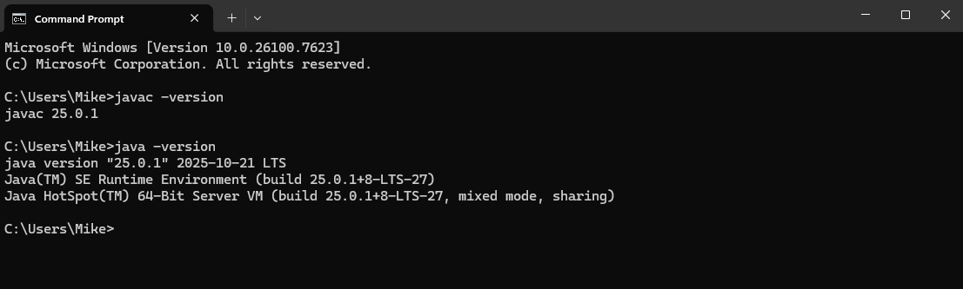
1.3 Assignment: JavaFX Running
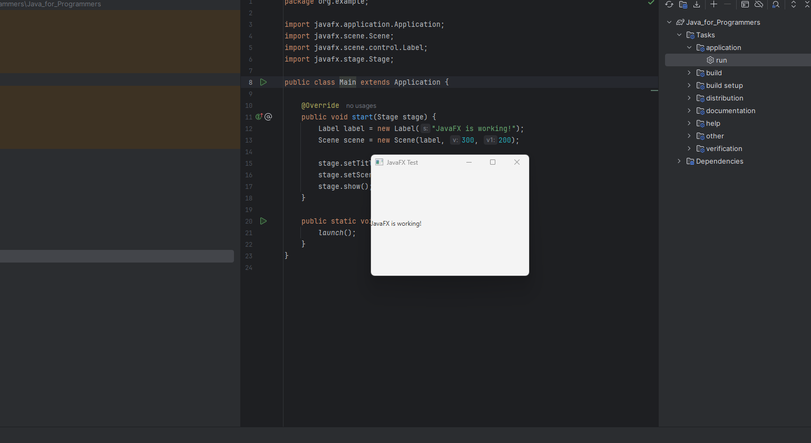

1.3 Assignment: Energy Needed to Heat Water Programming Assignment
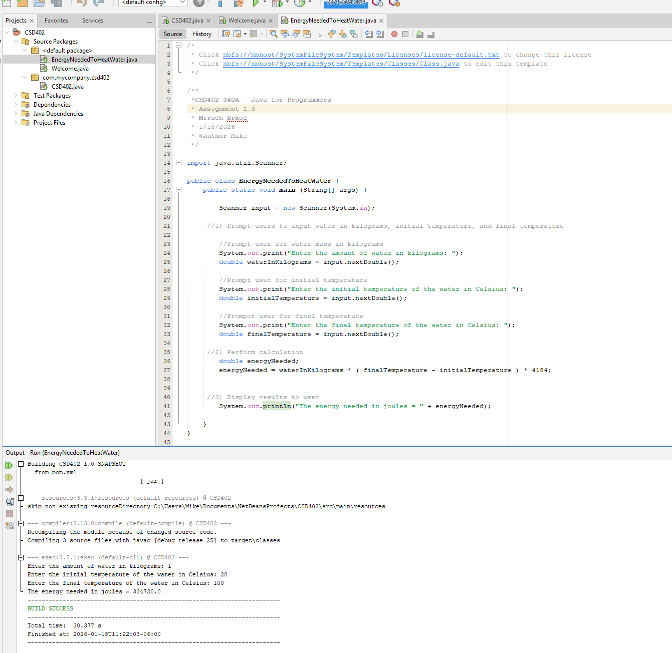

References:

https://github.com/Mikey5007/csd-402.git

